Cloud Computing Lab 2

Name : Manohar Mahesh Hegde
SRN : PES1UG23CS350
Section : F

SS1 : events page
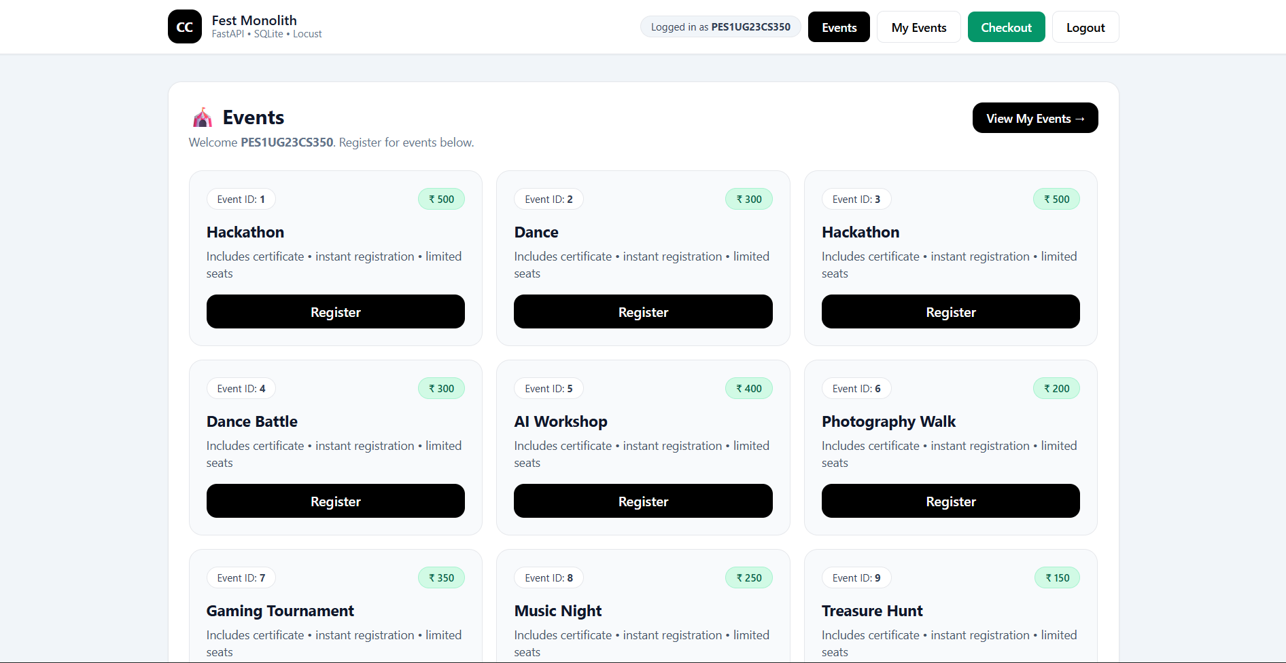

SS2 : Checkout page
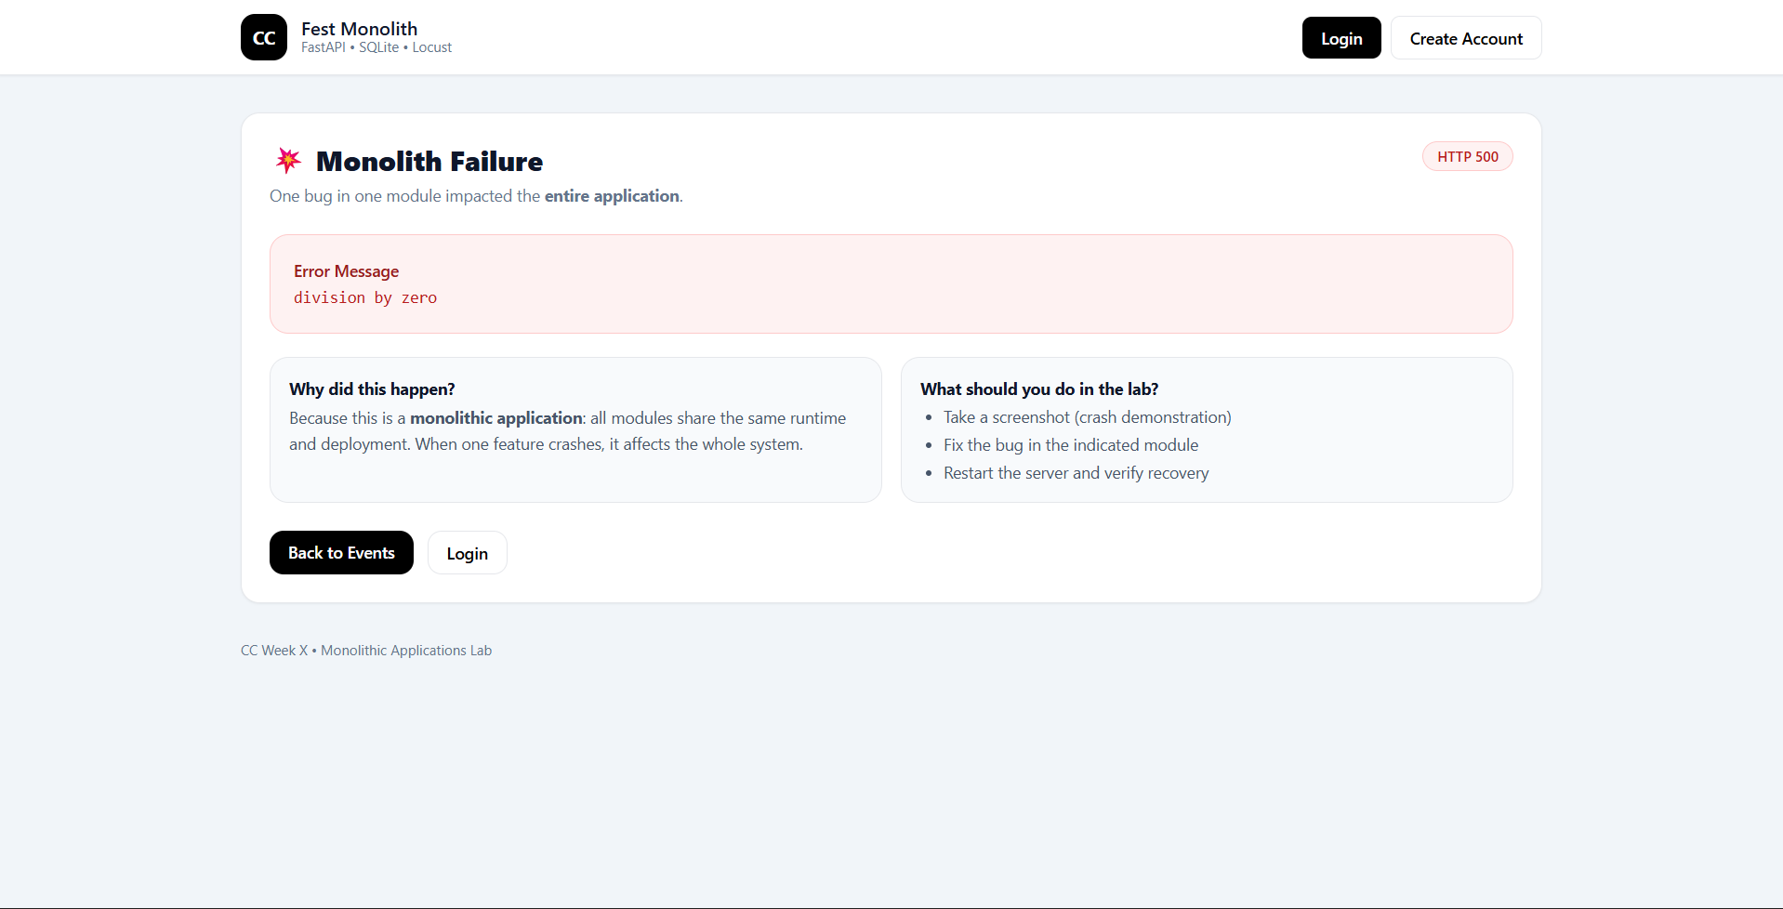

SS3 : working checkout
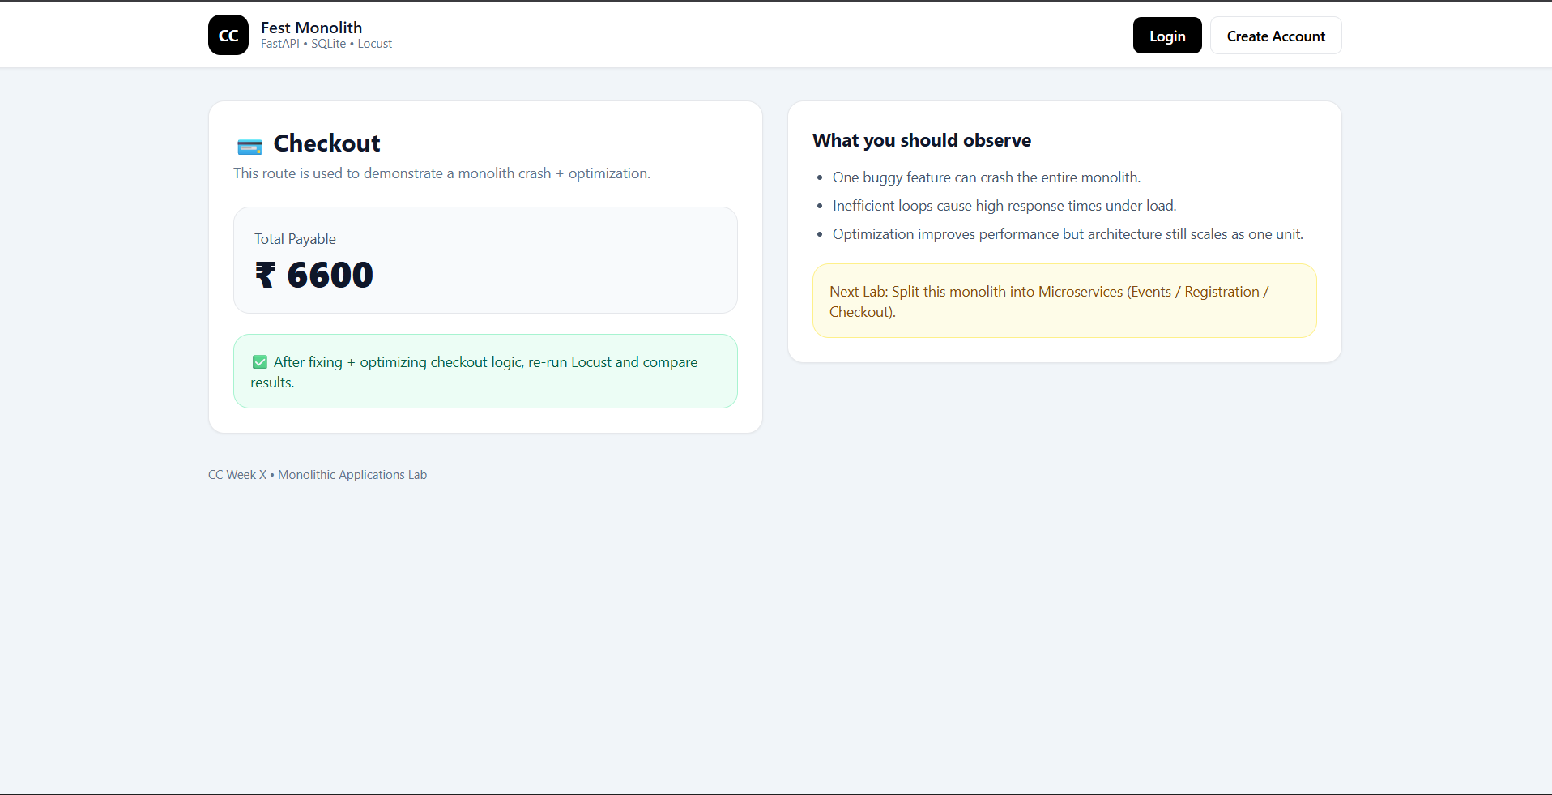

SS4 : Locust
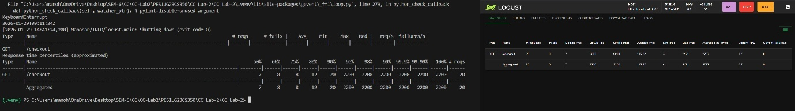
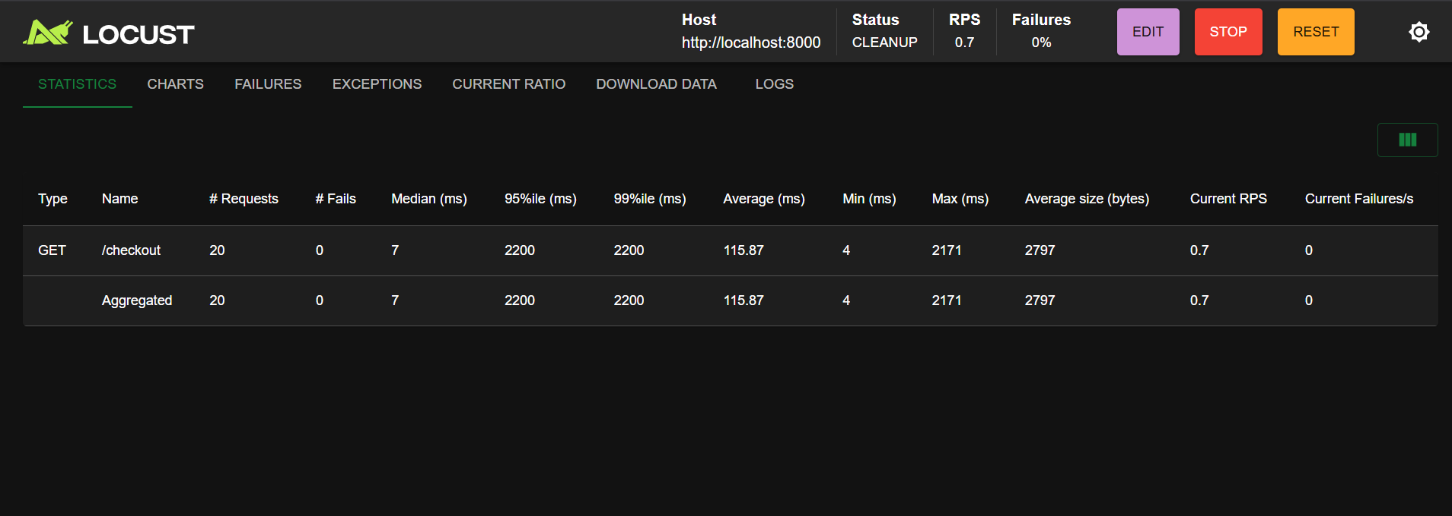


SS5 : after optimizing
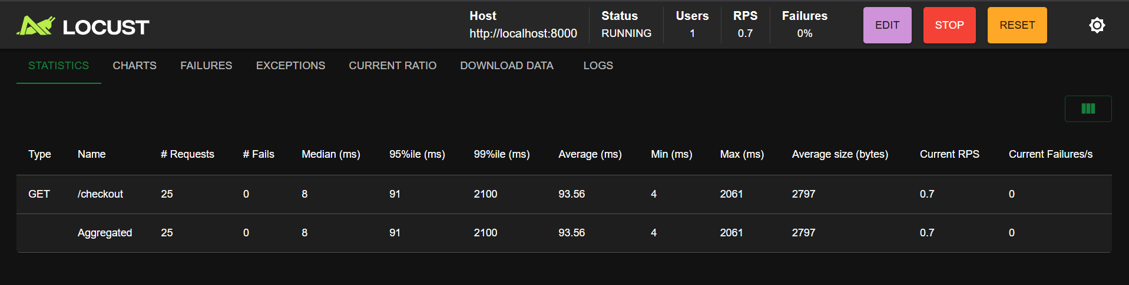
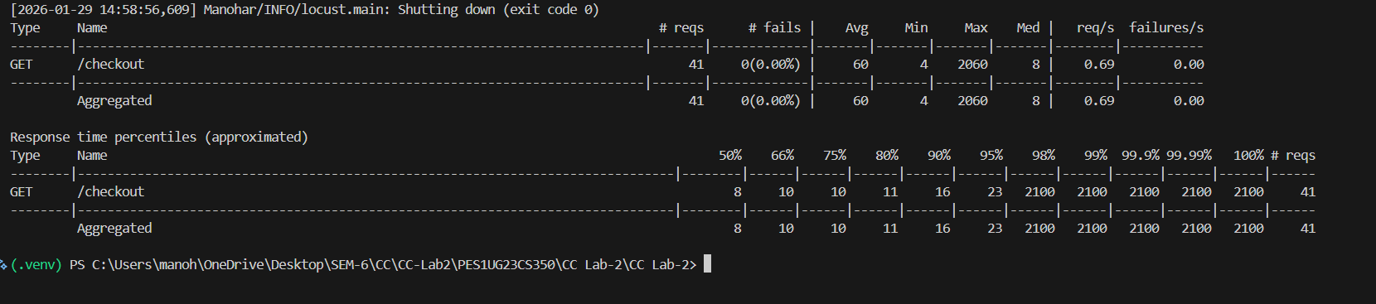

SS6 : events before optimization :
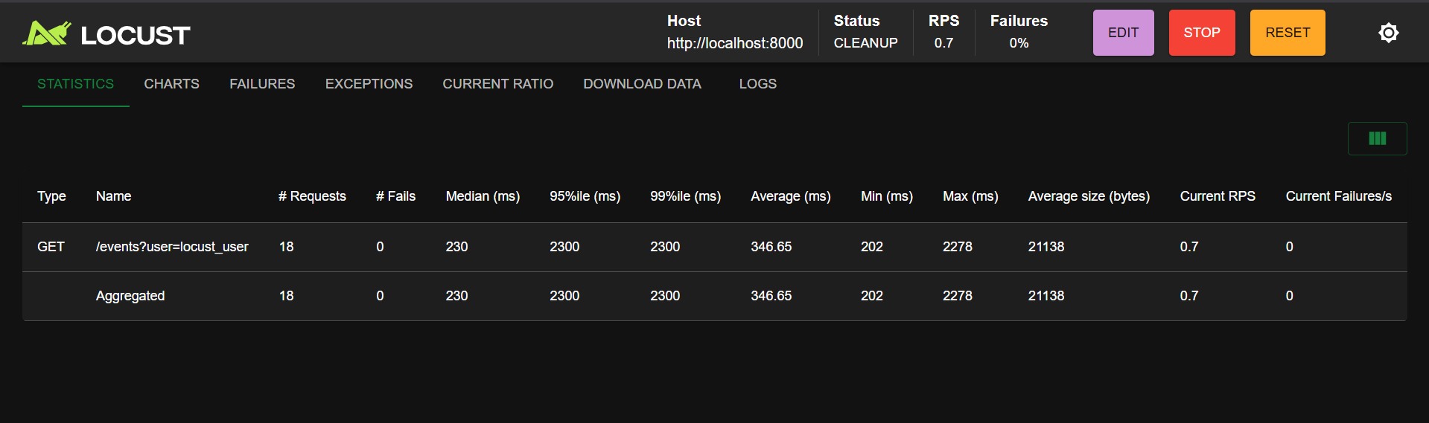
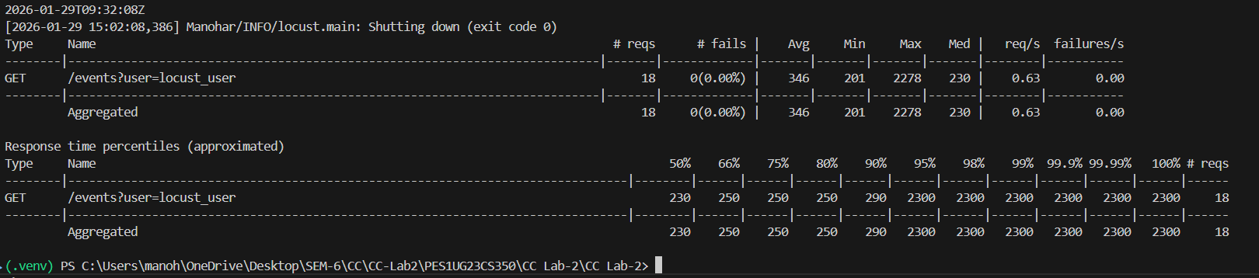

SS7 : events after optimization :

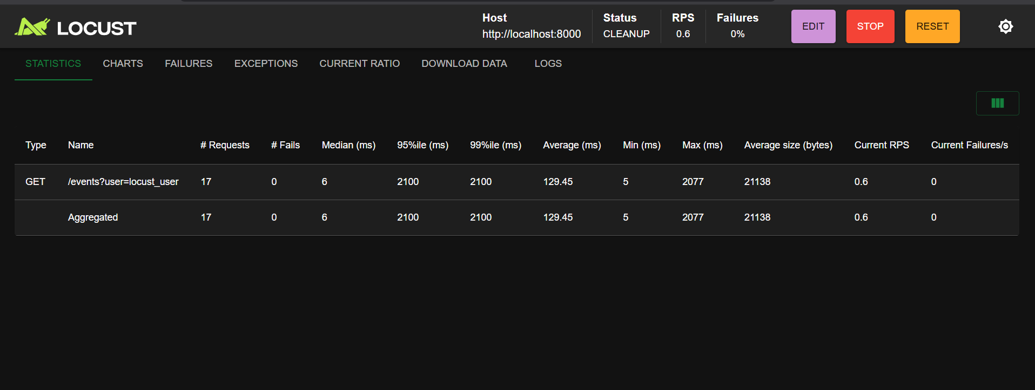
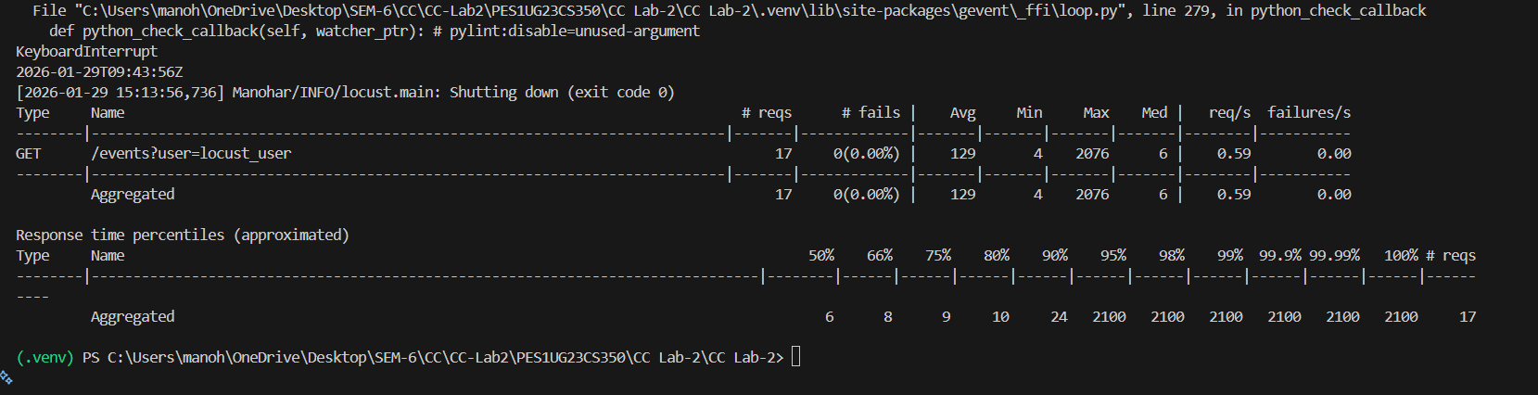
Since there was a useless for loop in the code, each request was going through loop several times , and was taking time ,but after removal of for loop the average time was drastically reduced.

SS8 : before optimization :
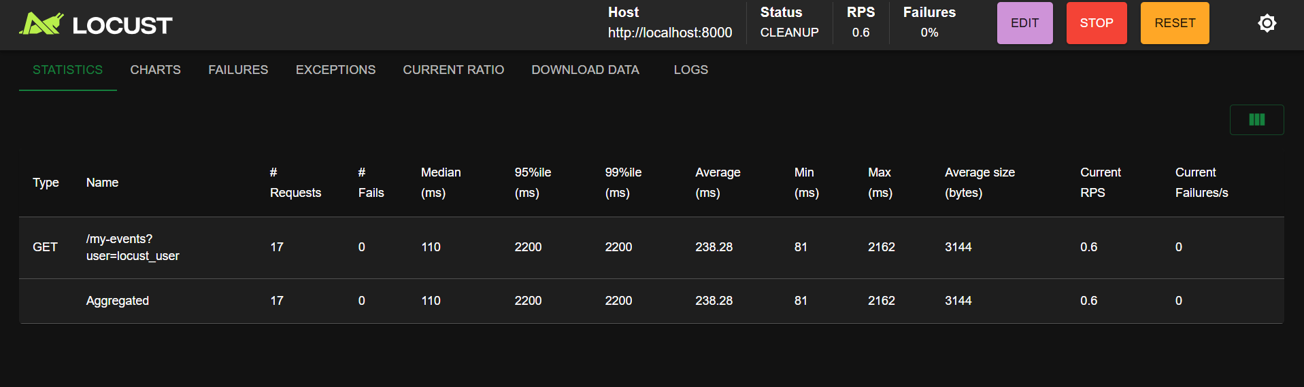
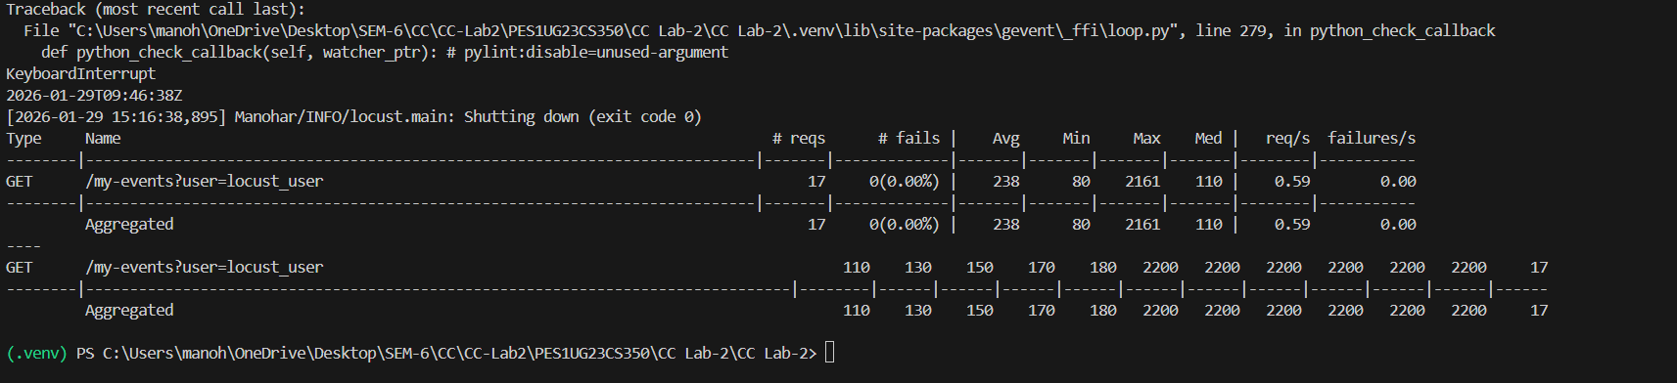

SS9 : After optimization
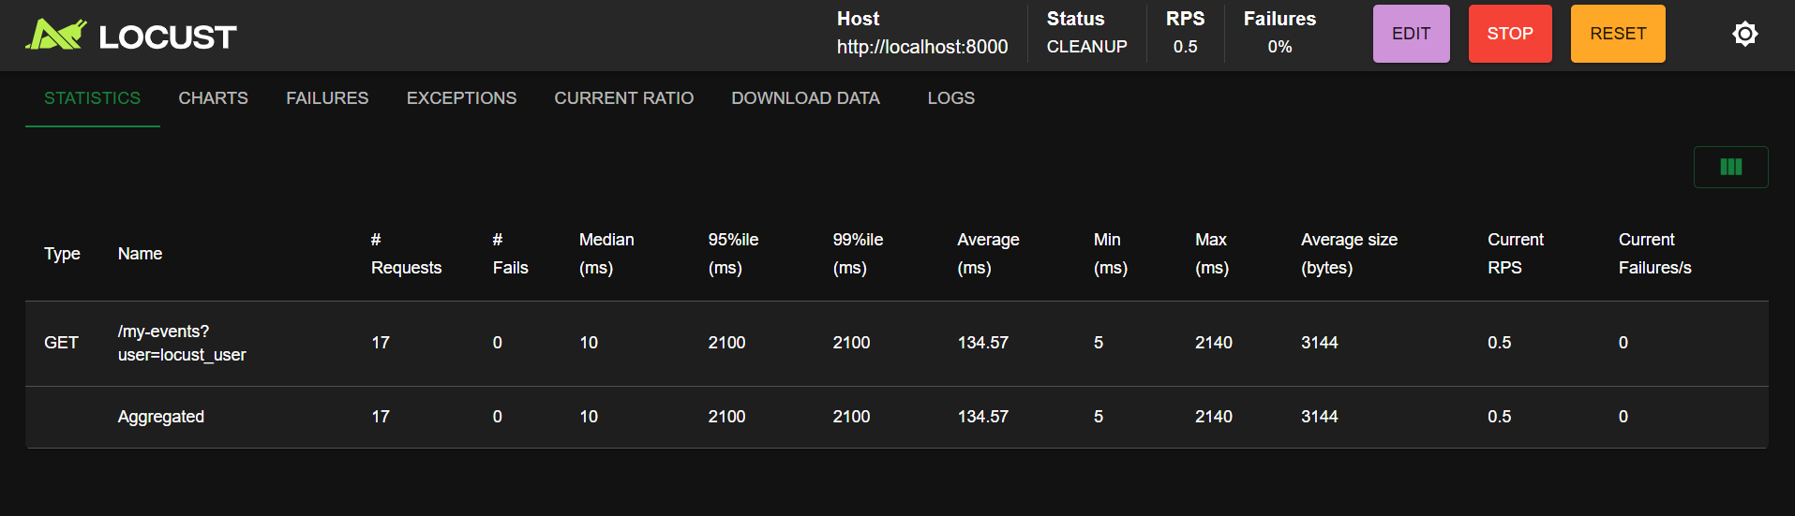
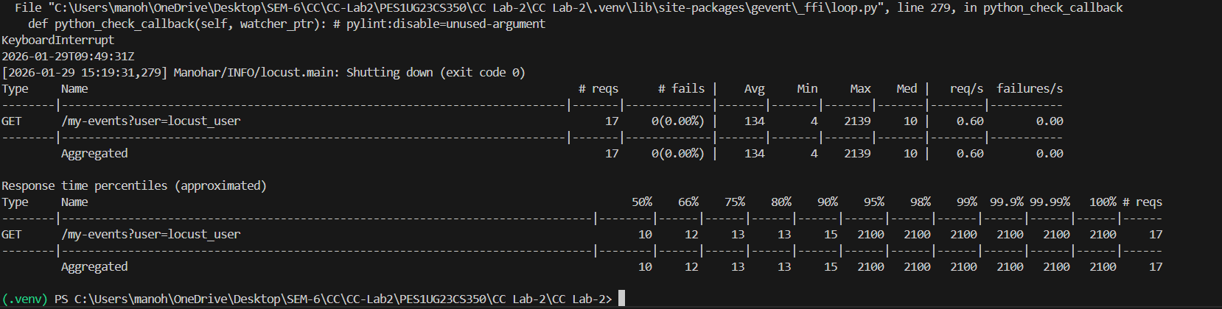

Since there was a useless for loop in the code, each request was going through loop several times , and was taking time ,but after removal of for loop the average time was drastically reduced.

For both routes:
● What was the bottleneck?
For loop in the code which was unnecessary.
● What change did you make?
Removal of the for loop in the code
● Why did the performance improve?
Since for each request made, loop was running 30000 times without any real purpose which was taking a lot of time , but after removal of the for loop time taken was drastically reduced and hence the growth in performance.

